

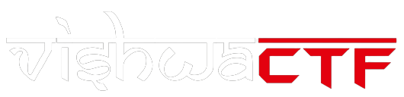

**CHALLENGE NAME : [Red Suit Secrets]**

**DEV : [Manjiree Sanap & Kanishk Kumar]**

**CATEGORY : [ Steganography]**

**LEVEL :** **[ Medium]**

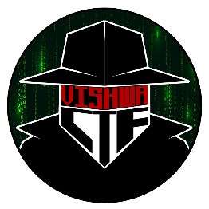





**2024**

**CHallenge Name :** **[Red Suit Secrets]**

]



**Question:** I’m a canine merc with a witty jest,

**1**

A mask and swords, I fight the best.

In a pool of blood, I rule.

Who am I, in this comic book duel?

The password is the name of my favourite Pet

**Description:** In this challenge, you will be working with encrypted audio and image files. Follow the steps for uncover the hidden flag.

**1)Audio Encryption:** You have an audio file that has been encrypted using Deepsound. The password used for encryption is ‘DOGPOOL’.

**2)Image extraction**: After decrypting the audio file, you will find the image file hdden within it. This image has been encrypted using Steghide. For decryption the image you have to use this or other some command like ‘steghide extract -sf lab.jpg’ and password is related tp hidden data in image then put this password ‘VANESSA_CARLYSLE’.

**3)Final flag:** Extract and decrypt the image to reveal the flag. The flag will be in format

**‘RecruitmentCTF{De@d_is_C00L}’**

**Hint:**

1.Challenge is related to Deadpool.

2.To decode the audio you need the window’s tool, just search **Deep** enough.

DEV : [Manjiree Sanap & Kanishk Kumar

$ ]